Data Visualization & Reporting for IT
Project: Phase 3
Team: 16
Akash kumar Dineshkumar – 1234713222
Abijith Prakash - 1232536073
Naveen Mayathevar – 1233861644
Naga Dileep Garigapati - 1233174828

Section 1: The Dashboard
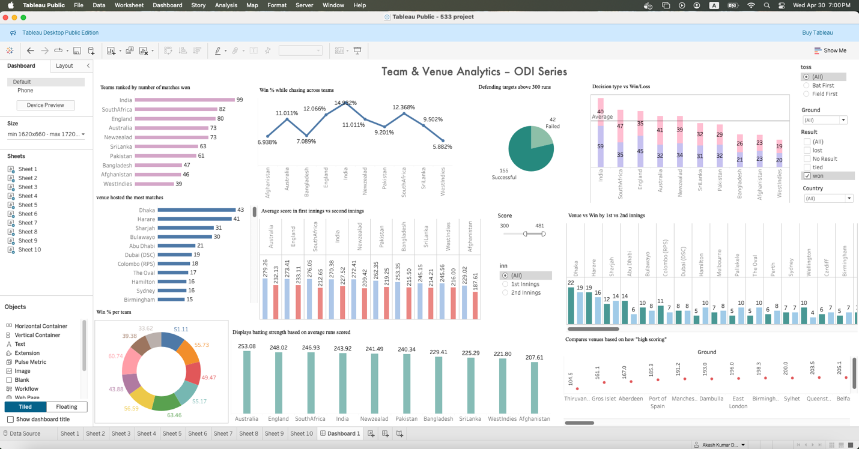
The dashboard gives an easy-to-understand and interactive snapshot of the ICC ODI World Cup 2019. The dashboard simplifies it for users to understand how different teams performed, how scores were converted from the first to the second inning, and through what means different teams won more frequently. Data was pre-processed and sanitized to remove errors and provide precise results alone. Tableau was used to prepare the dashboard, and it is filtered by team, venue, innings, and result so that the user can browse through segments easily. Trends can be determined with it, for instance, where high-scoring venues were or which teams employed better match strategy during the competition.

Section 2: The Dataset
The information utilized in this project has the entire data of the ICC ODI World Cup 2019, such as teams that took part in the tournament, their scores, result, date of match, match venues, etc. The data was cleaned before creating the dashboard to make it workable with. For example, scores were divided to get only the runs, extra strings in team names were removed, dates were normalized to the correct format, and result entries were normalized. This enabled us to have precise data that could be used to produce informative and clear visualizations.
Section 3: Dashboard Users
This dashboard is for whoever would like to view team and match performance during the ICC ODI World Cup 2019. It can be helpful for fans who would like to view the performance of teams at different venues or innings. Coaches, analysts, and sports strategists can utilize it to view trends like the success of chasing vs defending. The students or researchers using data analytics can also use the dashboard to see how the data of actual sports can be represented and comprehended. Its interactive nature helps ensure that individuals of any background are able to traverse the tournament in an astute manner.

Section 4: Questions
General Match & Team Performance Questions
- Which team won the most matches in the 2019 ICC World Cup?
- Which team had the highest average score across the tournament?
- Which team had the best win percentage during the tournament?
- Which venue hosted the most matches during the World Cup?
Location-Based Questions
- Which city or venue had the highest average match scores?
- Which venues were more favorable for chasing teams?
Match Strategy Questions
- How often did teams win when choosing to bat first vs field first?
- What was the average score in the first innings compared to the second innings?
- Which teams performed better while chasing targets instead of setting them?
- What was the success rate for teams defending targets above 300 runs?

Section 5: Plots
Plot 1:
Which team won the most matches during the ODI series?
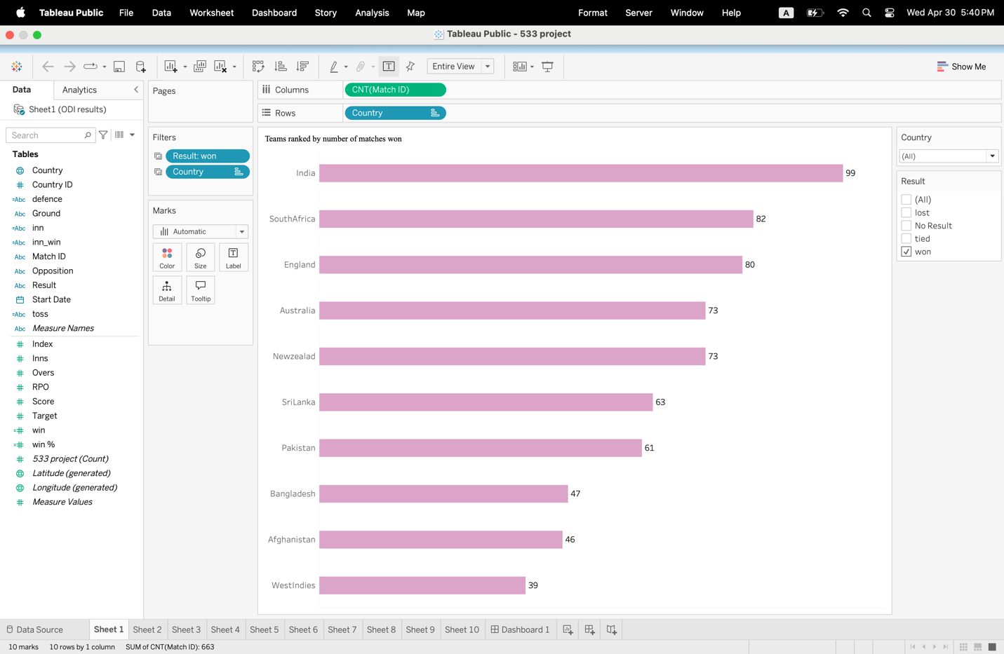
This horizontal bar graph has a Y-axis containing the list of all teams and displays the number of matches won by each team on the X-axis. There is a filter that shows only results in which teams have won. It facilitates comparison of team success easily.

Plot 2:
Which teams had the highest average runs scored in matches?
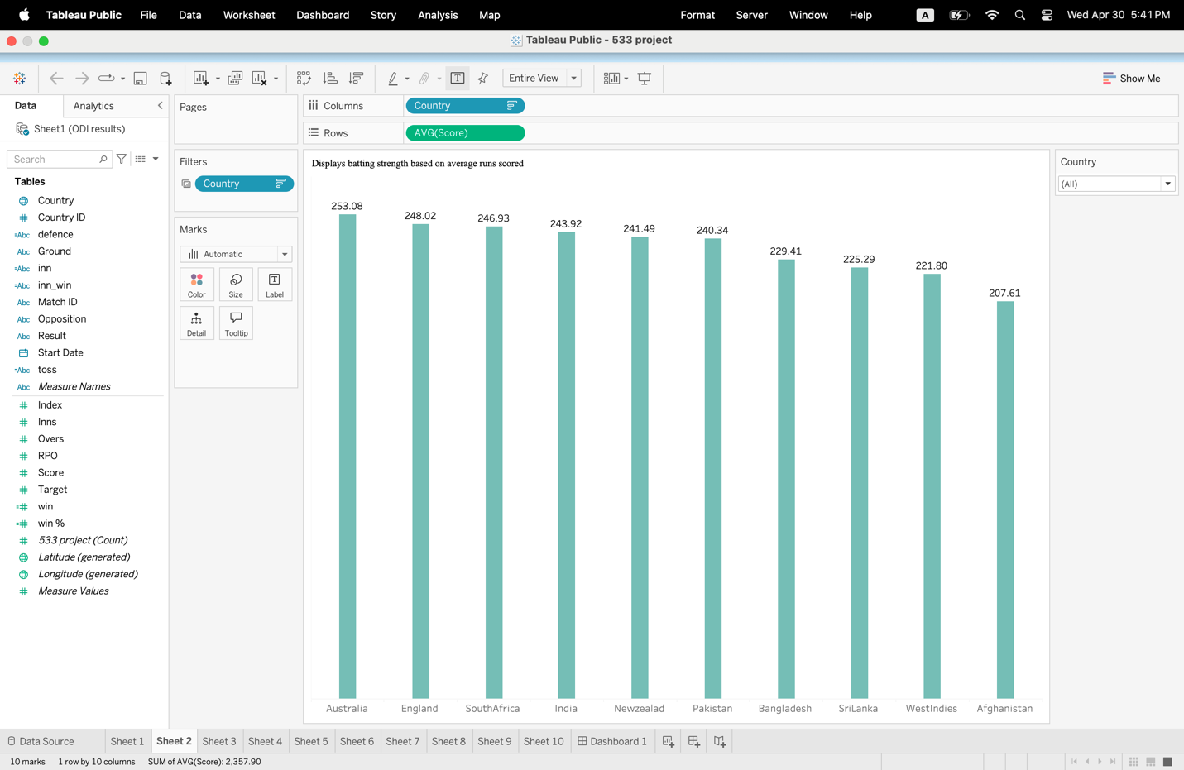
A vertical bar graph shows the mean of the "Score" field for each team, which shows batting power across the series. The taller the bar, the stronger the batting.

Plot 3:
What was each team's win percentage in the tournament?
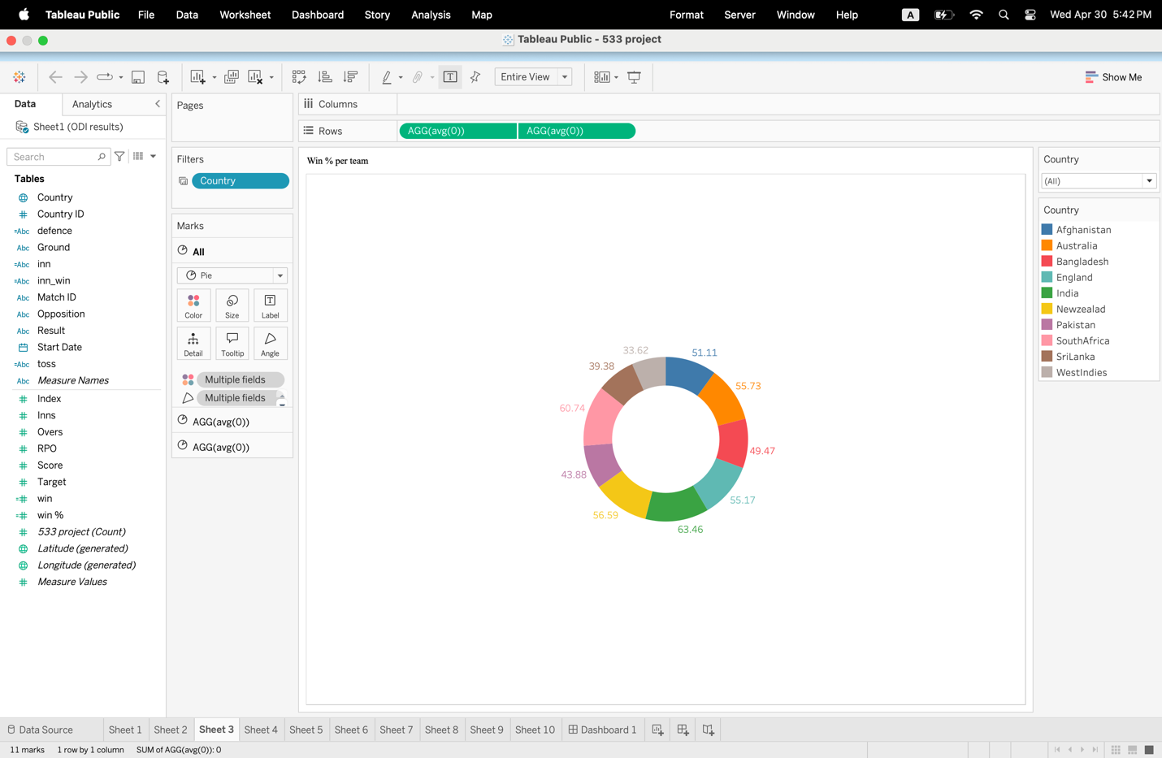
Donut chart displays win percentage for all teams through color-coded segments. It is sensible to measure efficiency in terms of wins over games played.

Plot 4:
Which venues hosted the most number of matches?
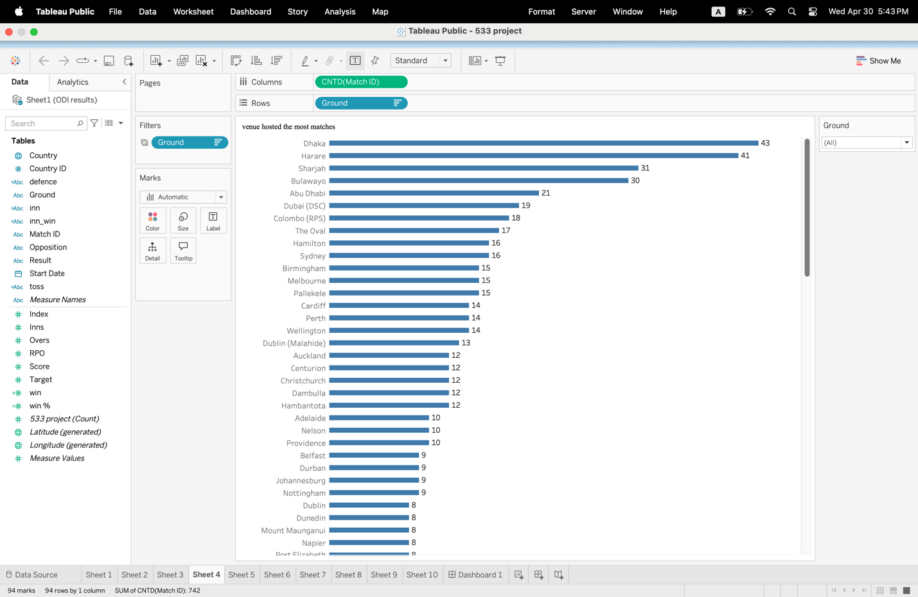
A horizontal bar chart sums up individual matches (based on Match ID) by ground. It plots the most utilized grounds in the tournament.

Plot 5:
Which venues were most favorable for high team scores?
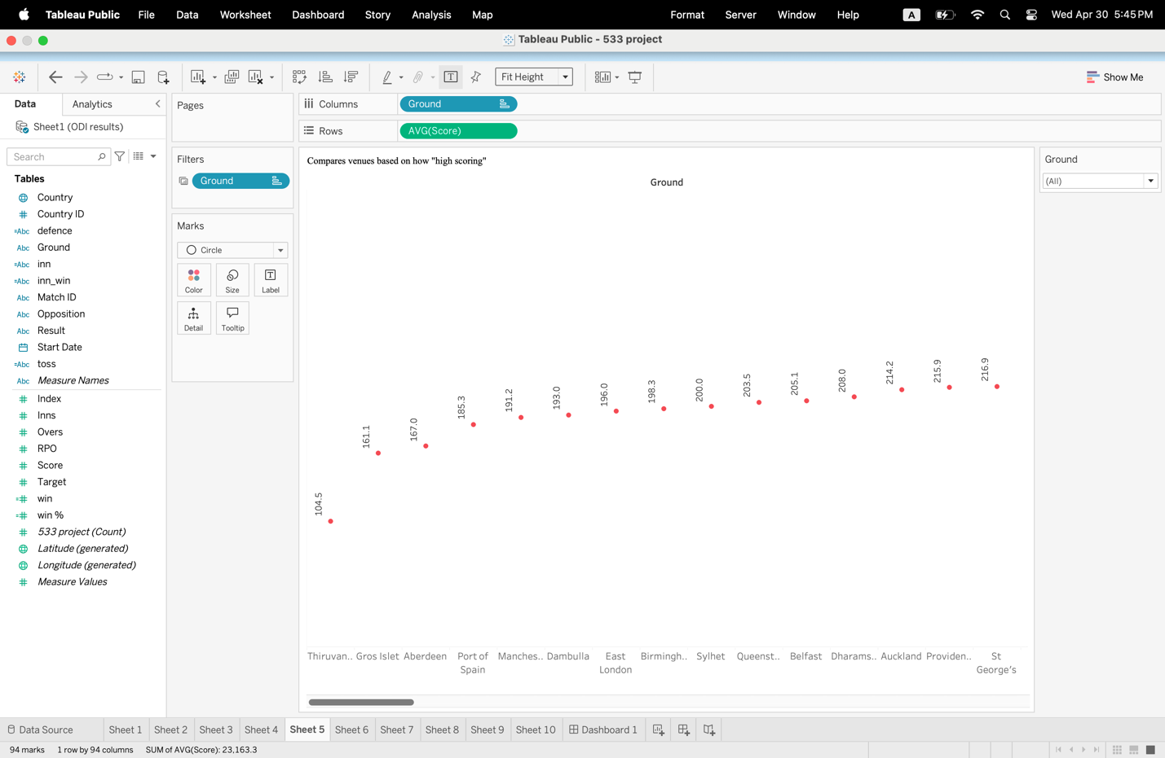
A circle plot indicates the average scores of teams on every ground. The higher the average score, the batting-friendlier the ground is rated.

Plot 6:
At different venues, do teams win more while batting first or second?
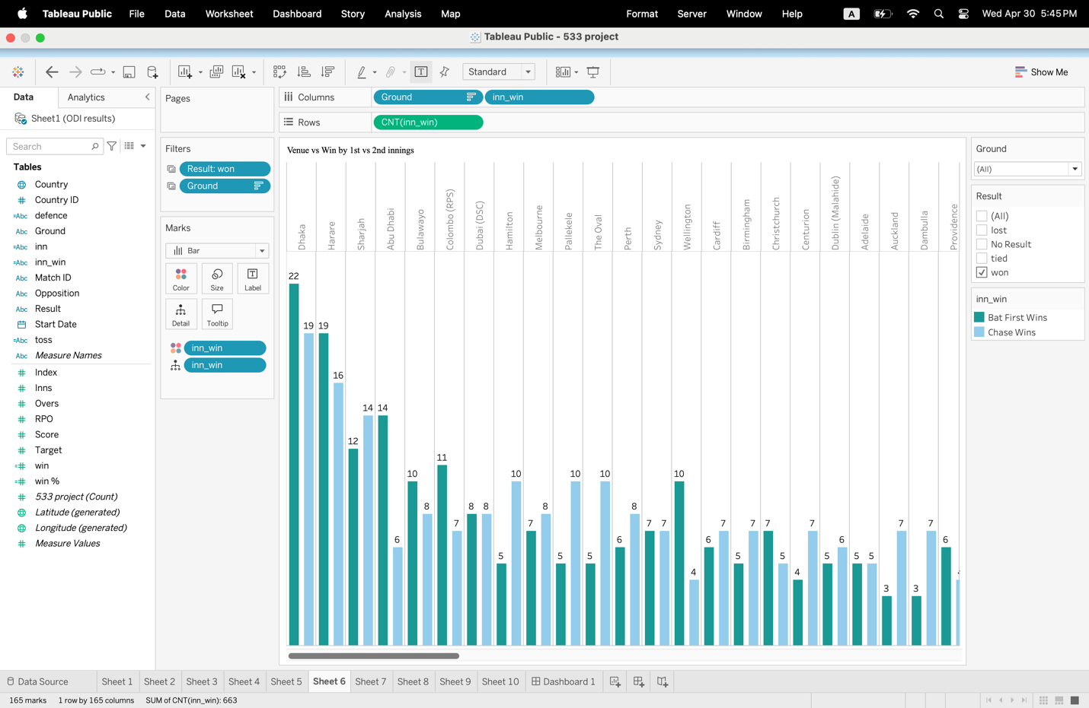
This grouped bar chart compares wins by innings at each ground. Blue bars represent first-innings wins, and light blue bars show second-innings wins. It reveals location-based winning trends.

Plot 7:
How did toss decisions (bat or field first) impact match outcomes?
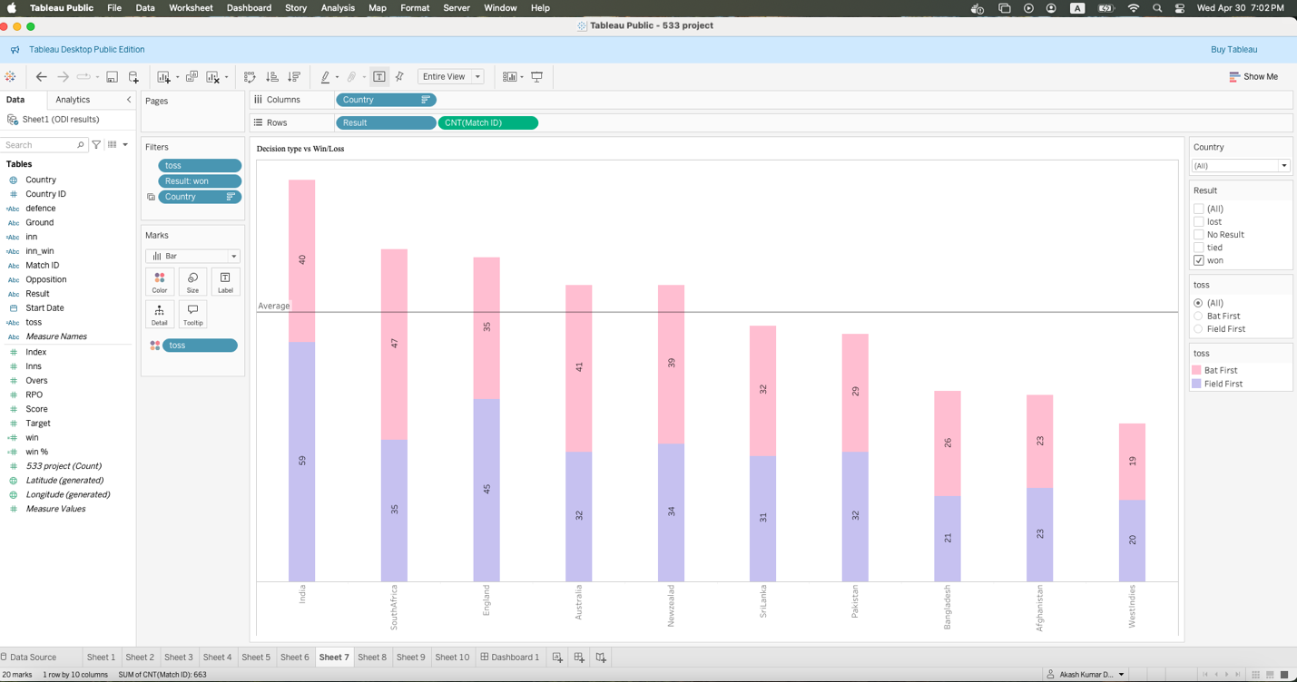
A stacked bar chart separates wins and losses by decision of toss. Every bar represents a team, with divisions for wins batting first vs fielding first. This highlights the effectiveness of decisions of toss.

Plot 8:
Do teams score more in the first or second innings?
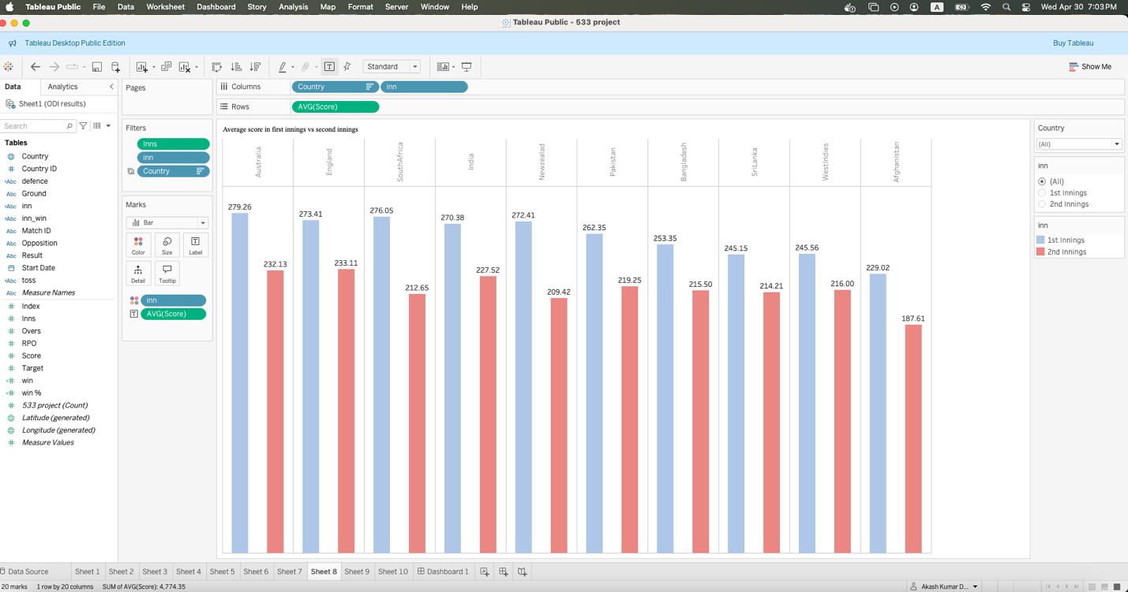
This two-color bar chart compares average scores of all teams for first and second innings. Blue is for first innings and red for second innings, so it is simple to visually compare.

Plot 9:
Which teams performed best when chasing a target?
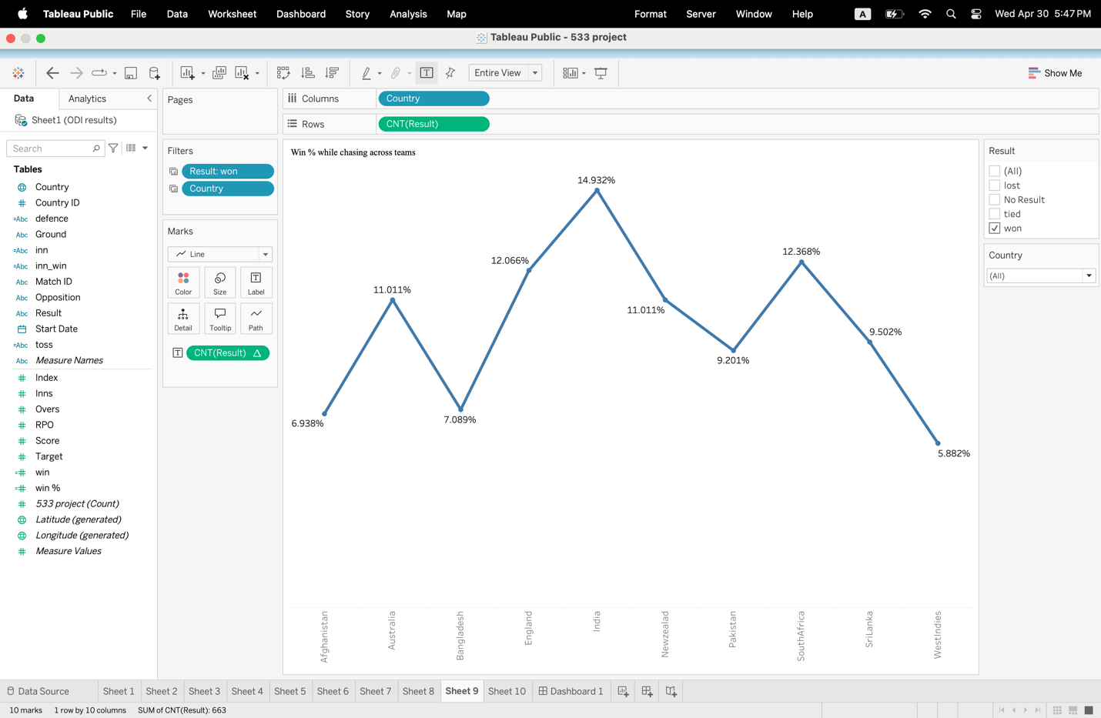
A line graph shows the percentage of matches each team won while chasing. It points out good chasing teams and provides information about match strategy.

Plot 10:
How often did teams successfully defend a total above 300 runs?
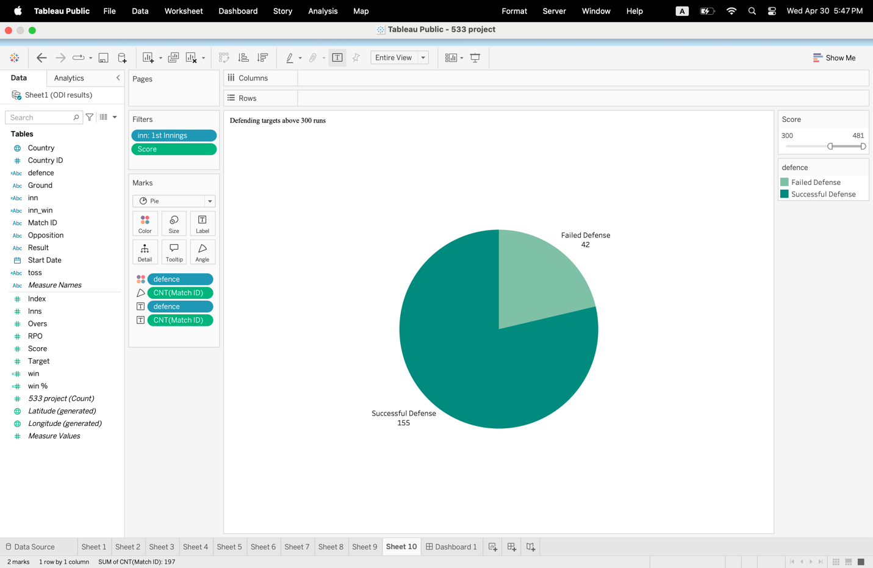
A pie chart divides matches into successful and failed defenses for scores above 300. It shows whether higher scores usually won when defending.

Section 6:
The dashboard has some interactive controls such that users can filter and look at the visualizations dynamically. A (Country) filter is included as a dropdown such that users can view plots relevant to their chosen team; it controls plots like total wins (Plot 1), average score (Plot 2), win percentage (Plot 3), toss decision impact (Plot 7), innings-wise runs (Plot 8), and chasing win percentage (Plot 9). There is also a result filter to filter individual match results (e.g., wins only) and is applied to most performance-based plots. There are also Ground filters to examine venue-based data on Plot 4, Plot 5, and Plot 6. Radio button control for innings (1st or 2nd) enables comparison in innings-wise scoring plots like Plot 8). A score slider has been incorporated in Plot 10 to view match results where teams have scored over a certain number (e.g., 300+). These filters make the dashboard highly interactive in nature, allowing personalized insights based on team, ground, match result, innings, and scoring criteria.
Country Filter: Plot 1, 2, 3, 7, 8
Ground Filter: Plot 4, 5, 6
Result Filter: Plot 1, 9, 6
Toss Filter: Plot 7
Inn Filter: Plot 8
Score Filter: Plot 10
Tableau Public Link: https://public.tableau.com/views/533project/Dashboard1?:language=en-US&publish=yes&:sid=&:redirect=auth&:display_count=n&:origin=viz_share_link

